**EXPERIMENT 4**

RELATIONAL MODEL FOR SAILOR BOAT DATABASE

**Aim:** Draw a relational model for sailors database

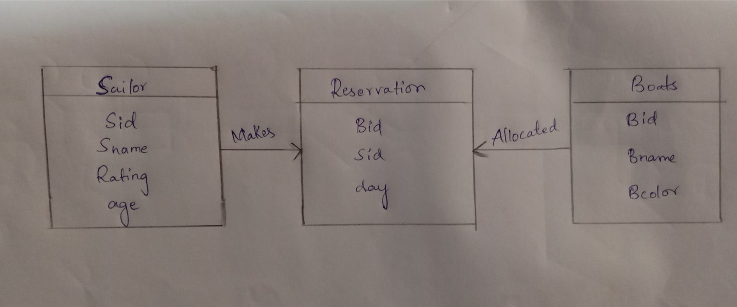

allocated

Sid

Bid

day

**Reservation**

Makes

Bid

Bname

Bcolor

**Boats**

**Sailor**

Sid

Sname

Rating

age